Bash-Scripting assignment-01.

1 create file with name test
Command : vi test
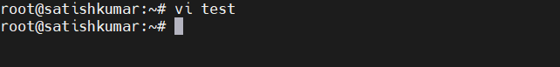
edit:
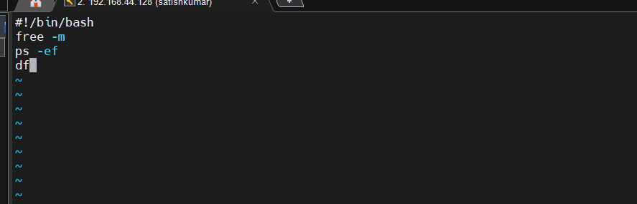
Add permission
Chmod 777 test
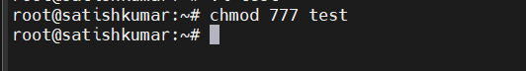
Execute
./ test
bash test
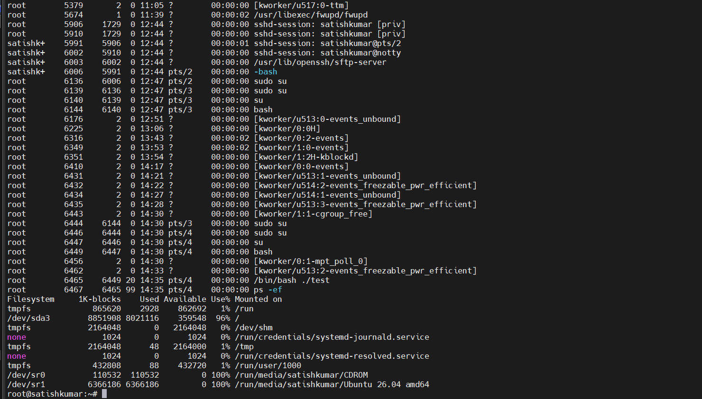
check shell
command : echo $0
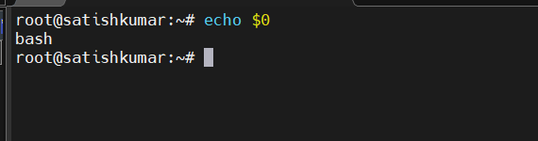

To check how many types of shells
Command : cat /etc/shells
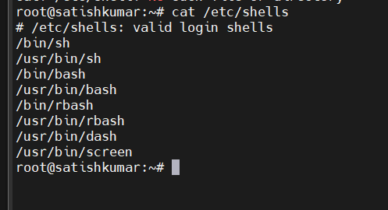

Check which user is associated with which shell
Command : cat /etc/passwd
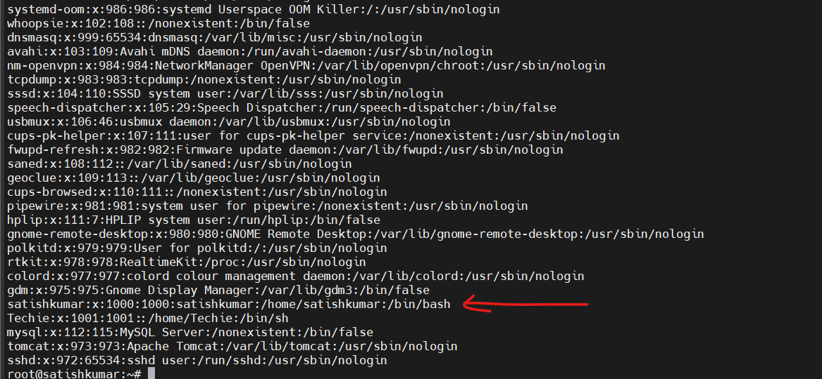
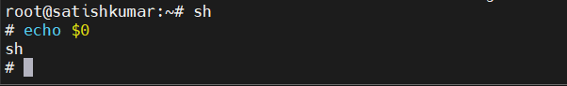
Create script
Check present directory
pwd
makdir -p /satishkumar/script2

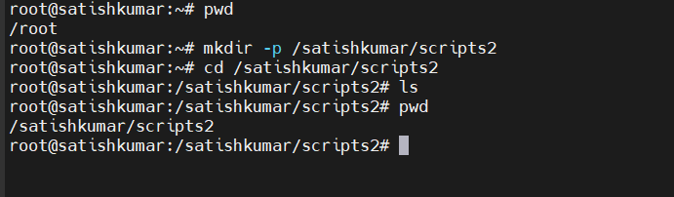

Create script : vi helloworld
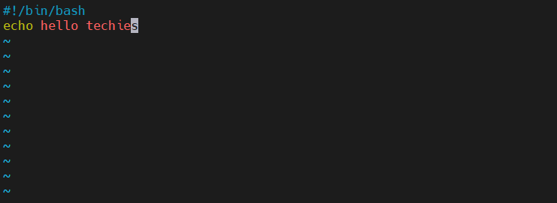c
Permission
chmod 755 helloworld
To check
./helloworld

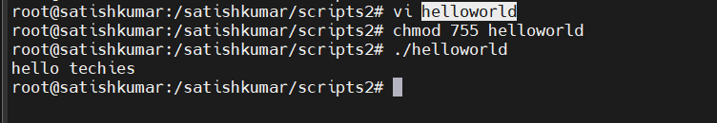
This is absolute path from root location to file

This is relative path access from file location
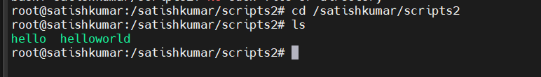
Bash helloworld

Create script abc.bash without permission
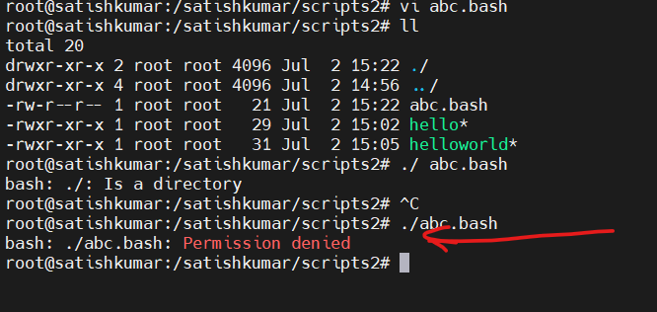
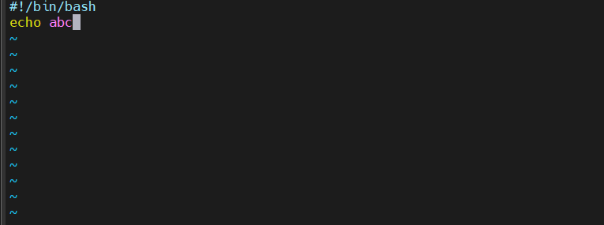
Add permission to abc.bash
chmod 755 abc.bash
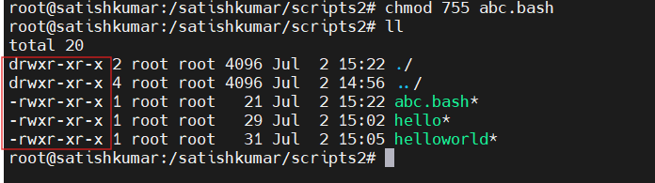

Script format
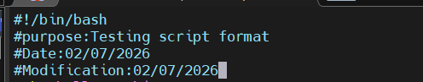

Variable
a =
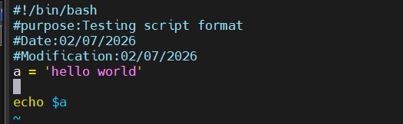
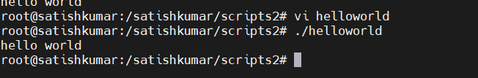
Note : Sequence of script : top to bottom

Create script with bash
Command : vi helloworld.bash
Chmod 755 helloworld.bash
./ helloworld.bash
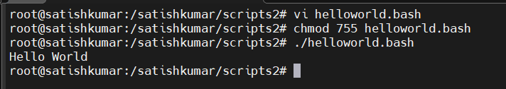
Create script commnd.bash
Command : vi command.bash
Write
pwd
ls
whoami
cal
touch a b c
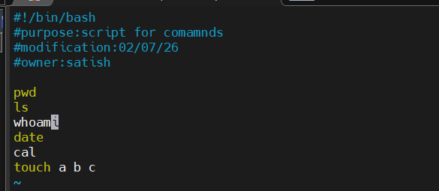
Permission
chmod 755 command.bash
execute
./command.bash
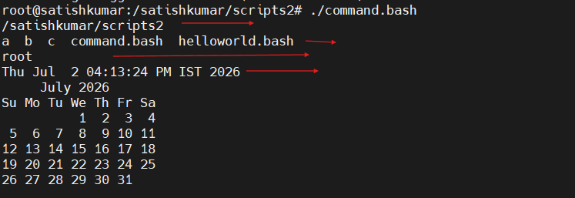

Create script for admin task
Vi admintask
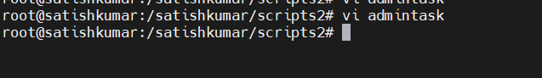
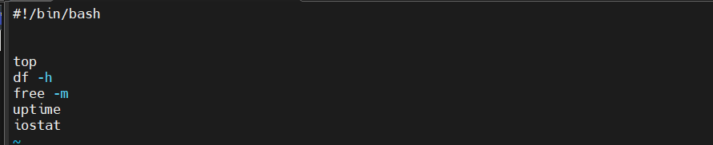
Permission and Execution:
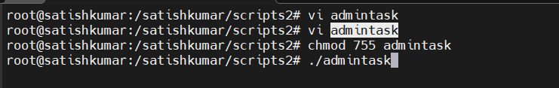
Output
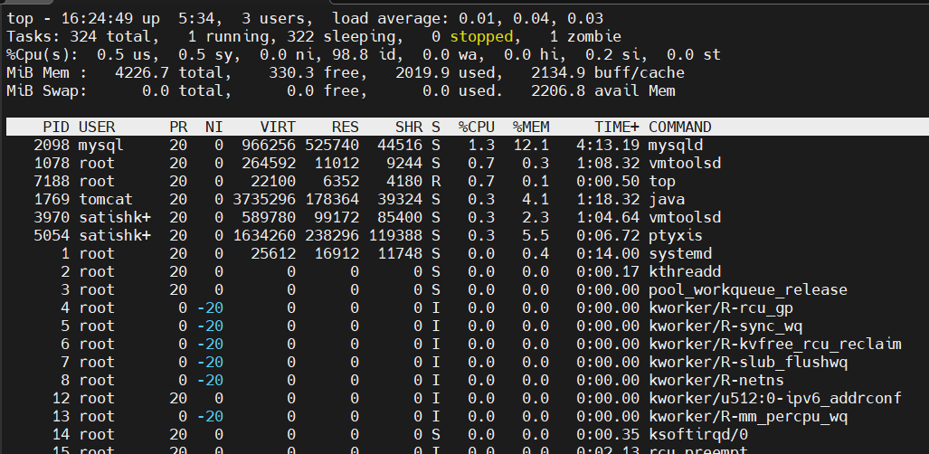
Note: Only top command executed because top command hold the session
Ctrl+c to see all
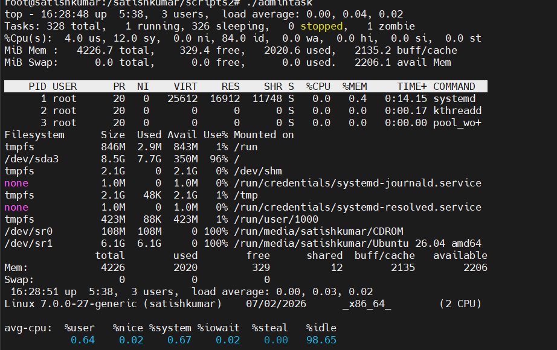
We can use head -10 to see top 10
Create script var100
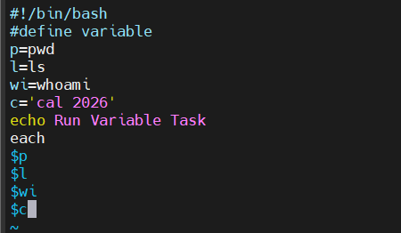

Output
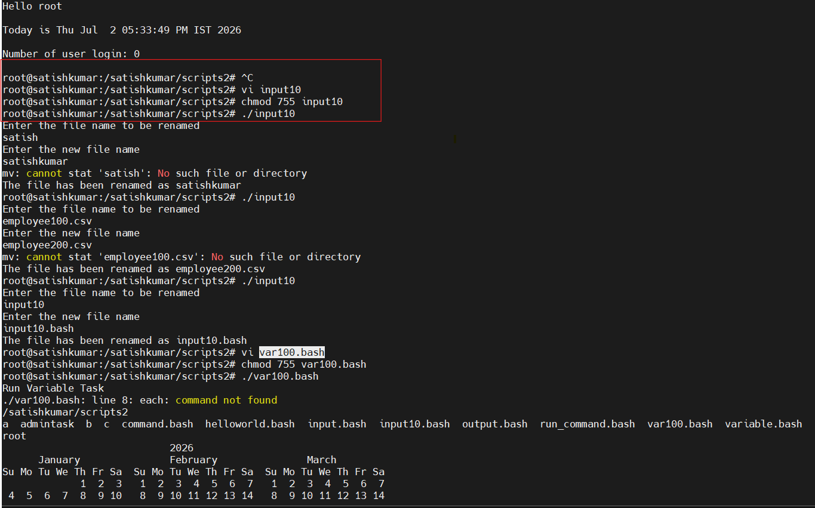

Create input100.bash
Vi input100.bash
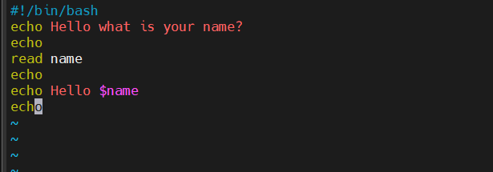

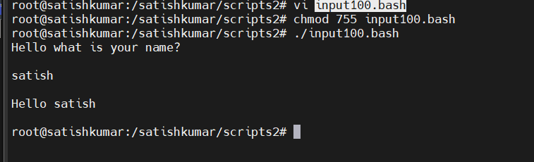

Create create output
#!/bin/bash
# Simple output script

echo "Hello World"
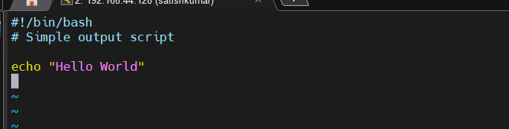

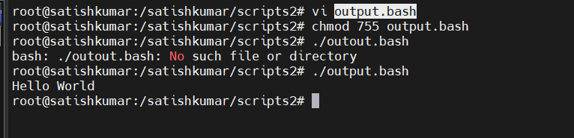

Defining variables
Create variable script
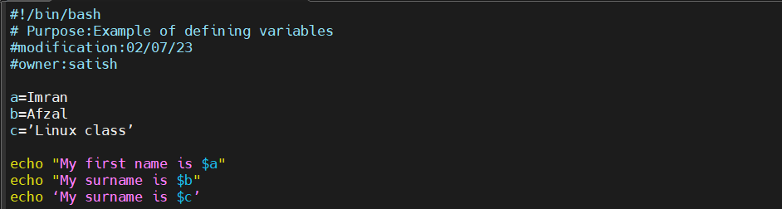
Execute
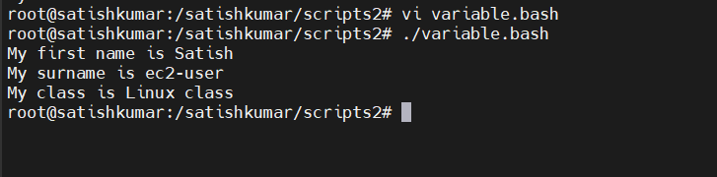

Read Input
Create script for input read
Vi input.bash
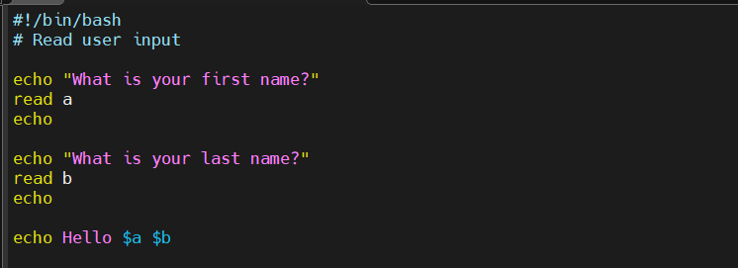
Output
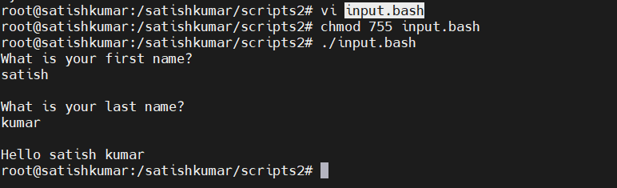

Scripts to run commands within

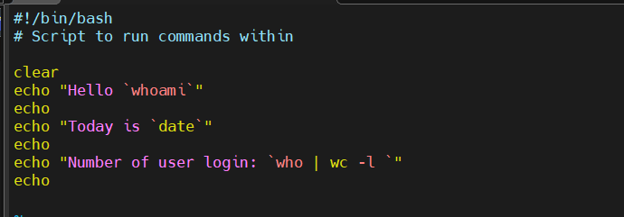
Execute
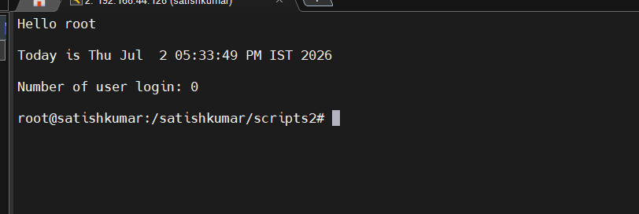
Read input and perform a task
Create script input10
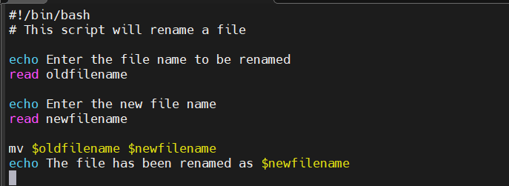
Output
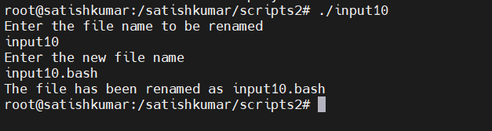.
Create case script
Input
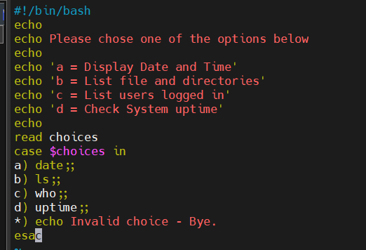
Output
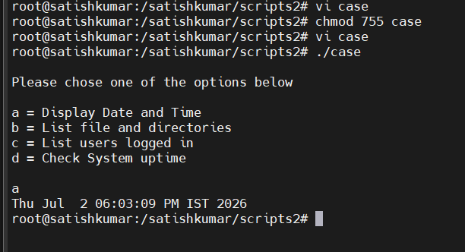

This script will look at your current day and tell you the state of the
Backup
Create case script
Vi case100.bash
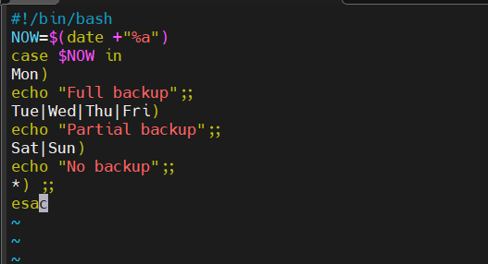
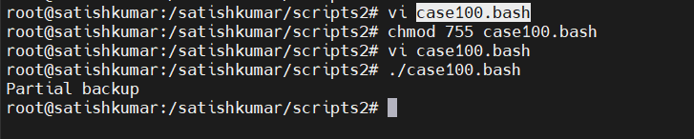

do-while Script
Script to run for a number of times
create while script
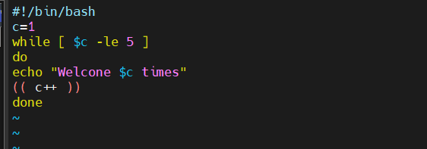
Ouput
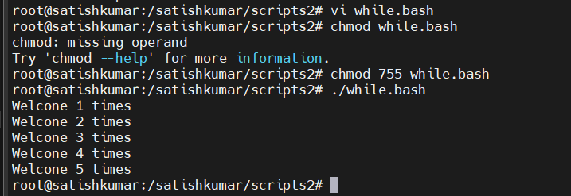

Script to run for a number of seconds
Input
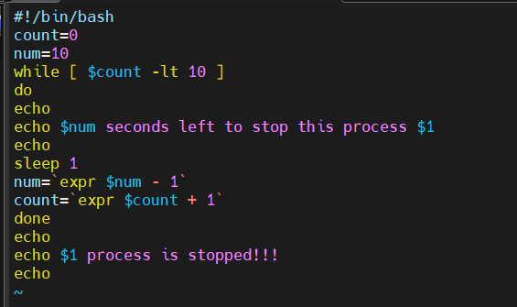
Output
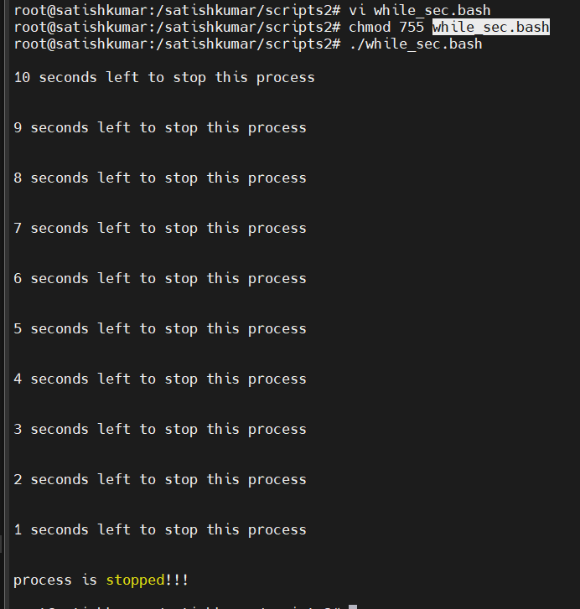

for loop Scripts:
Simple for loop output
Input
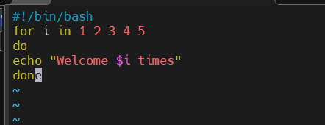

output
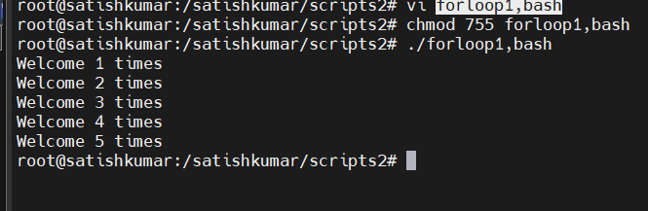
Create forloop
Vi forloop.bash
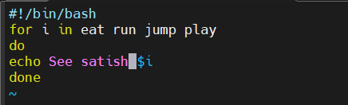
Output
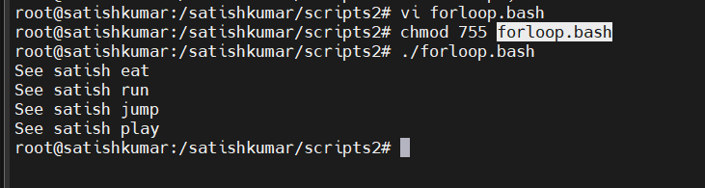

for loop to create 5 files named 1-5
